Download Vmware Workstation for Windows and install
https://www.vmware.com/products/desktop-hypervisor/workstation-and-fusion

- Check above blog, and install VMware Workstation on your personal laptop
- Download ubuntu 22.04

https://releases.ubuntu.com/22.04/?_gl=1*18xj4v4*_gcl_au*MTc2NDg4Nzk3NS4xNzIzNDM1Nzcw&_ga=2.238615232.1313284686.1723435768-641863381.1723435768

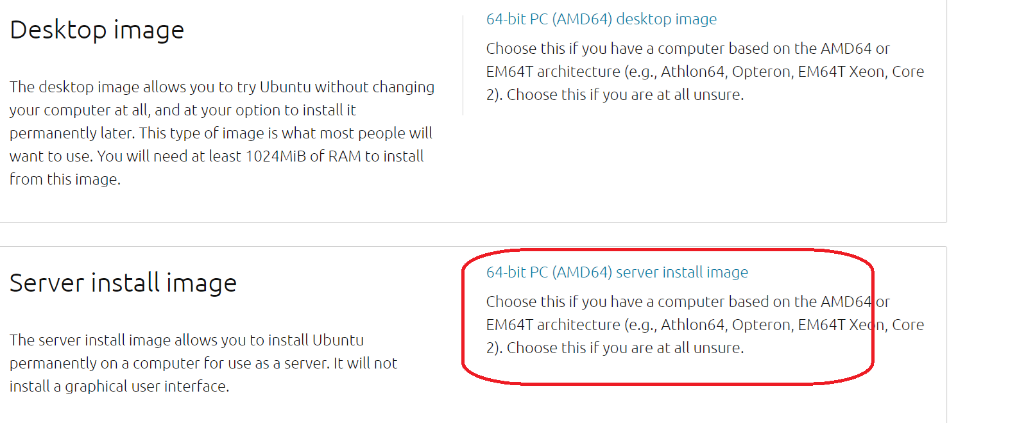

Image name: ubuntu-22.04.4-live-server-amd64.iso

Open VMware Workstation, and click
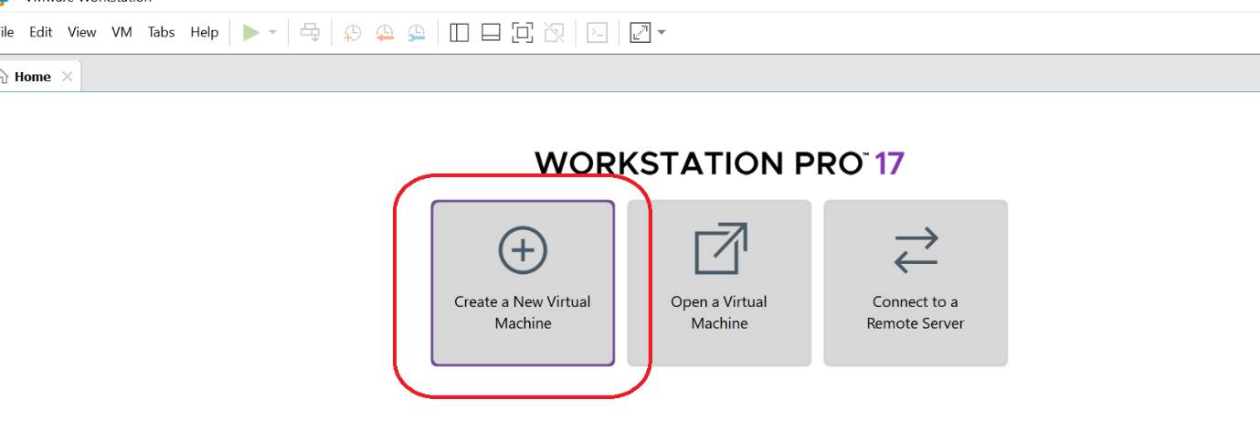

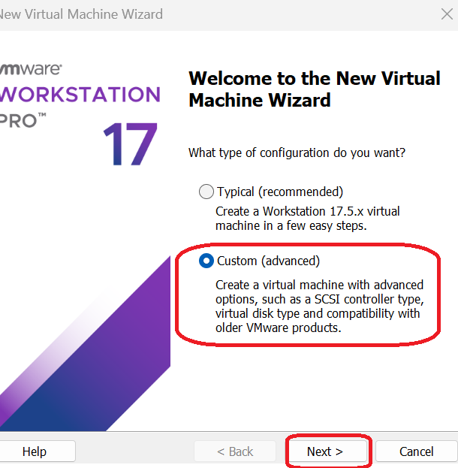

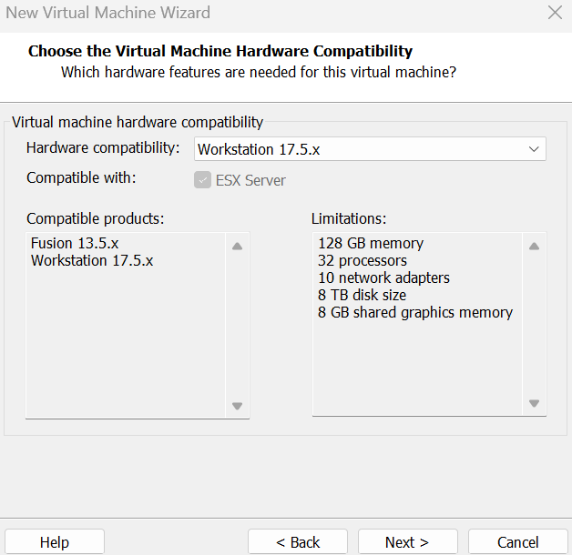
Select the iso which you downloaded

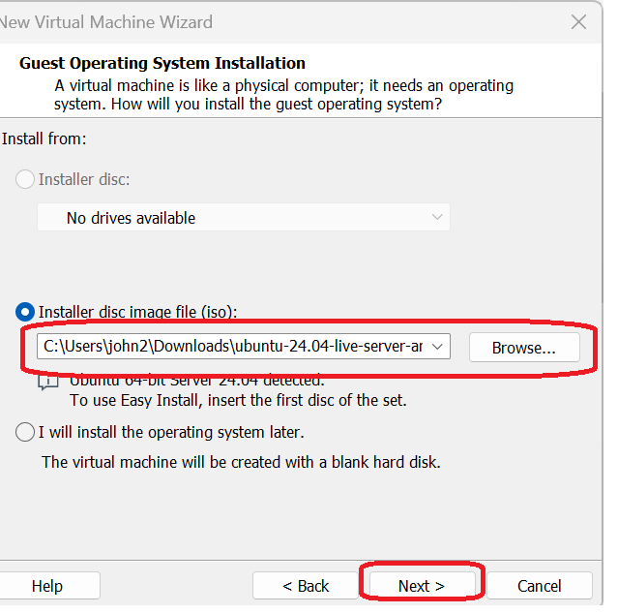

Provide a name and location
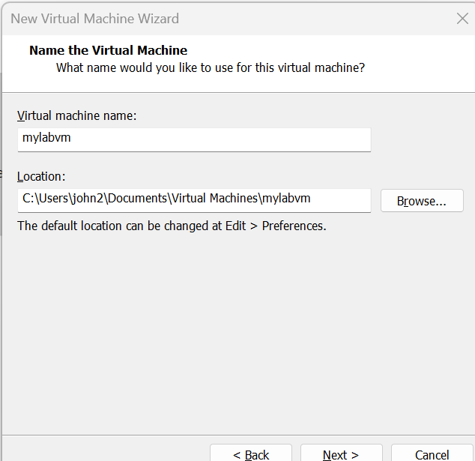
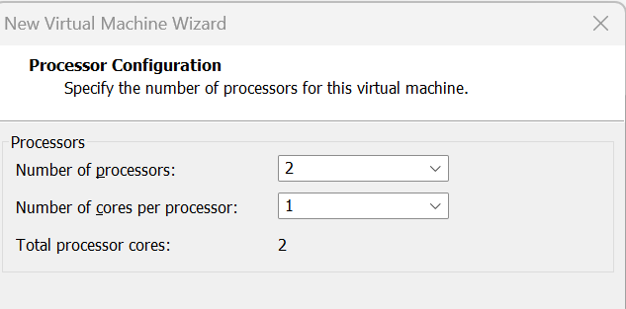

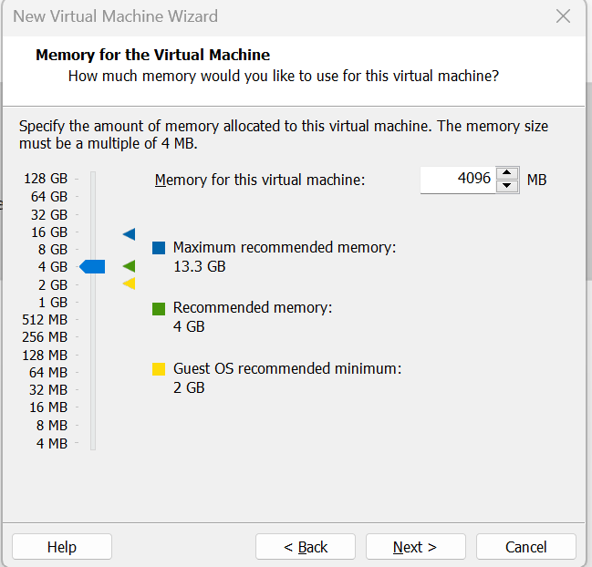

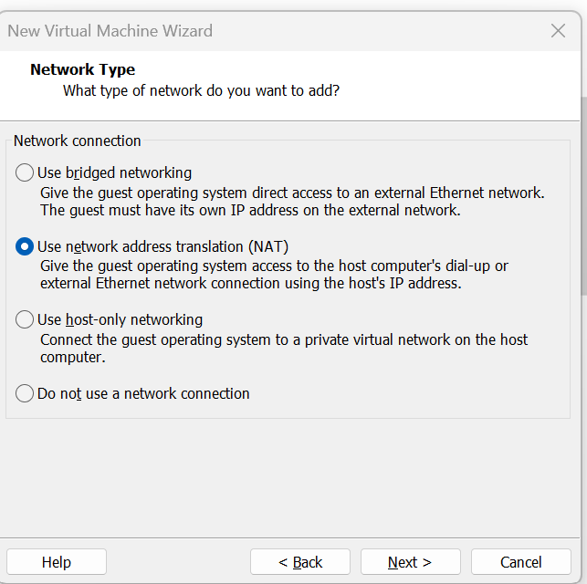
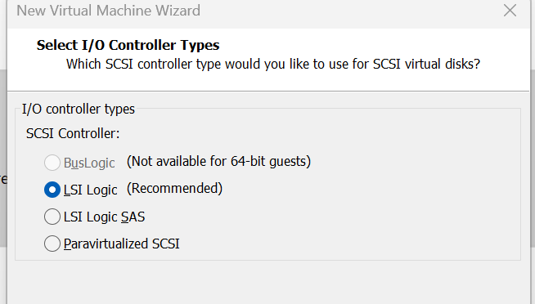
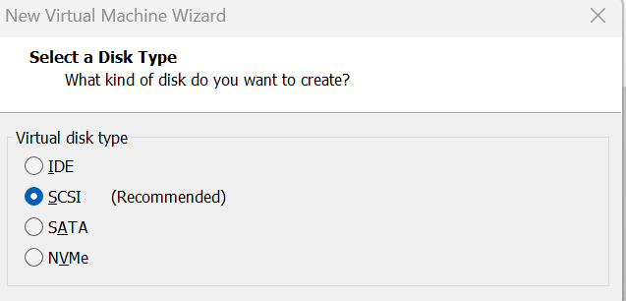
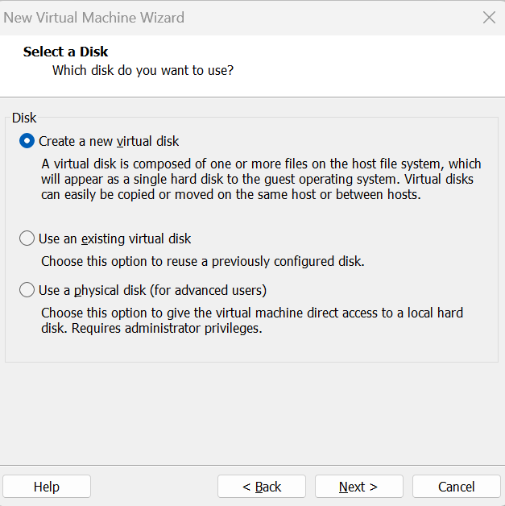
50 HD, and store as single file

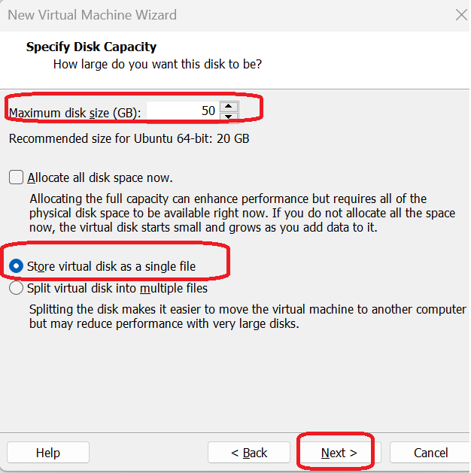
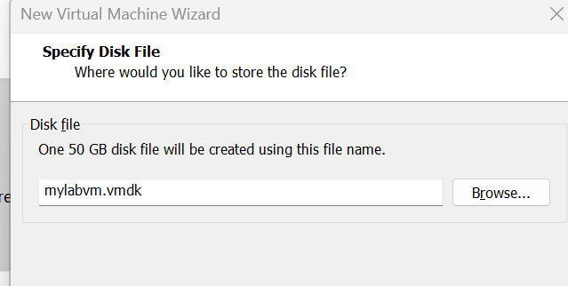

Click on finish
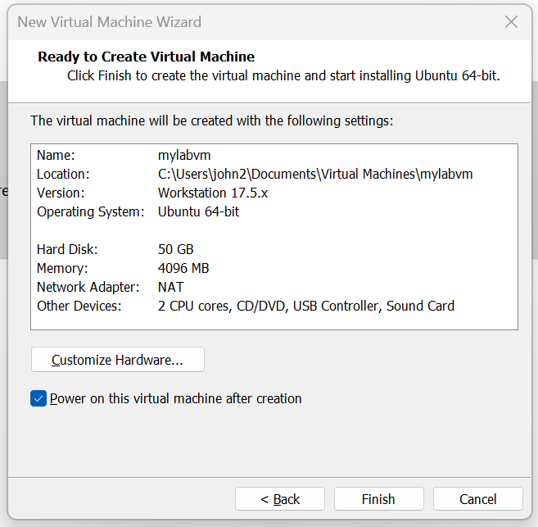

Using keyboard, Enter on Install ubuntu server
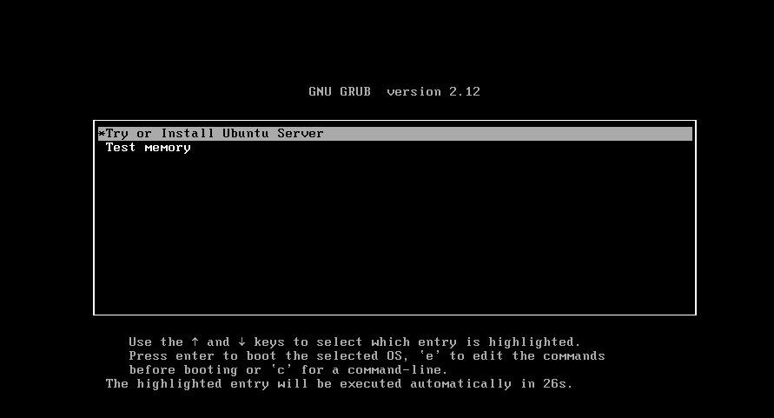

Select the language and press enter
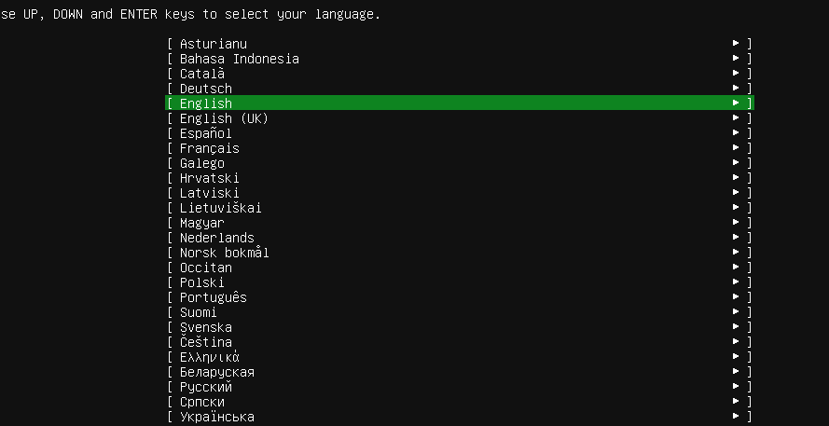

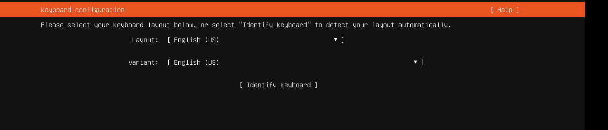
Press enter
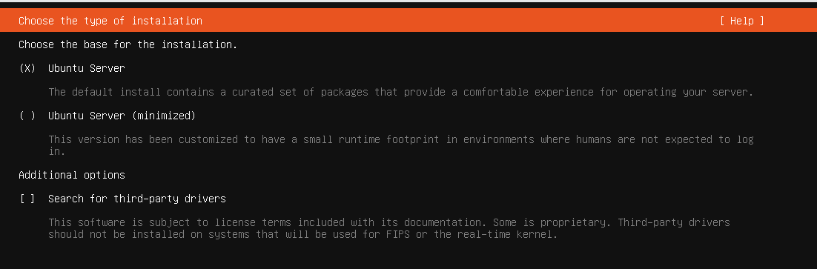
Default ip range, press enter
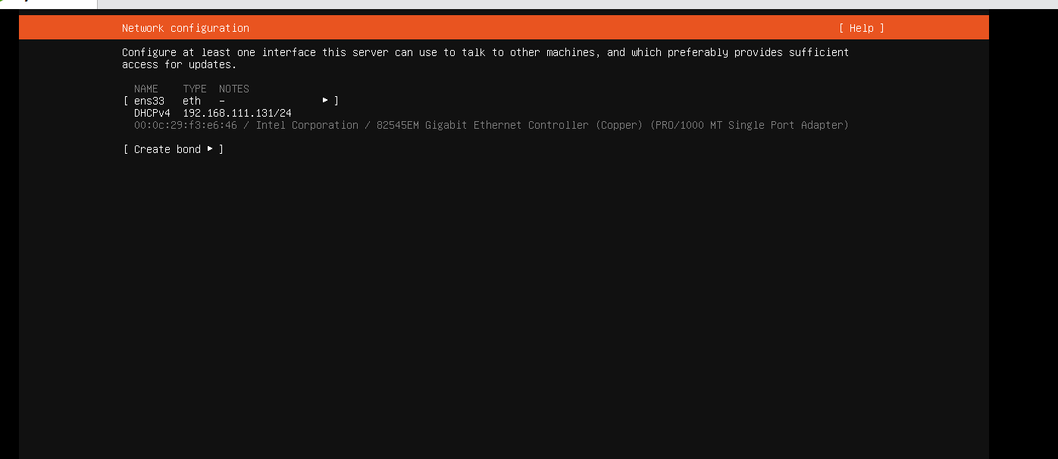No proxy
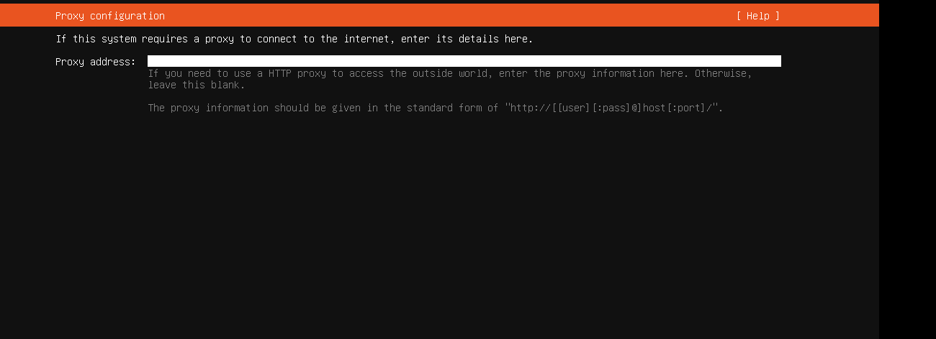
Press Enter
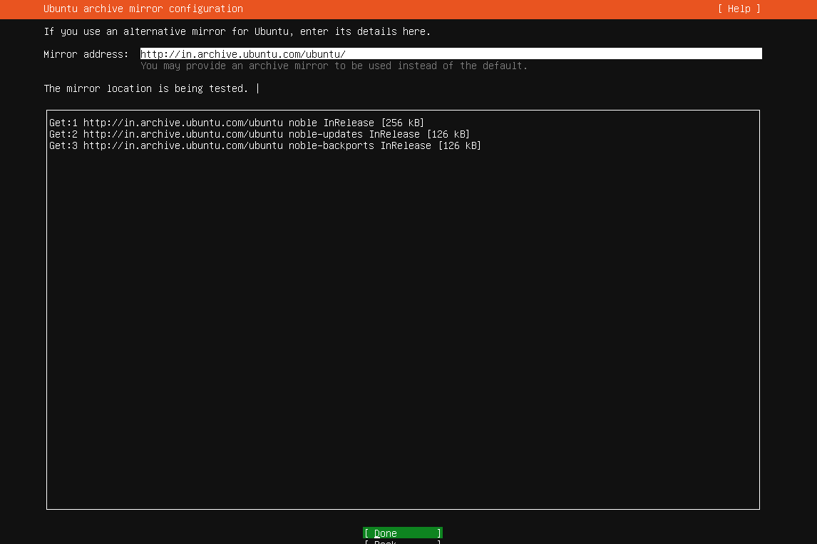
Using Tab go to done, and press Enter
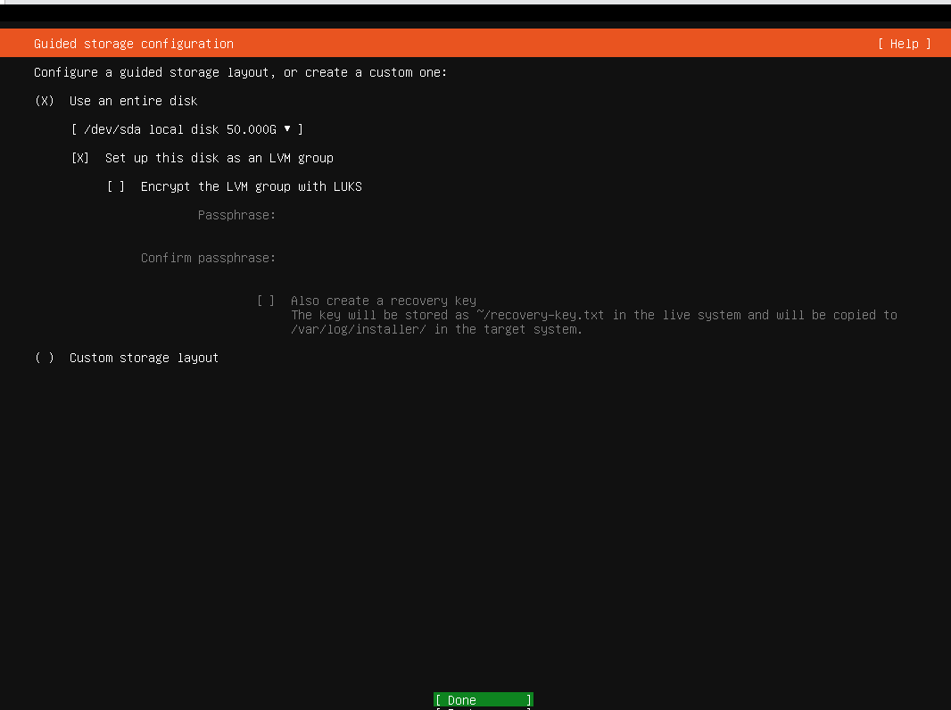

Enter on Continue
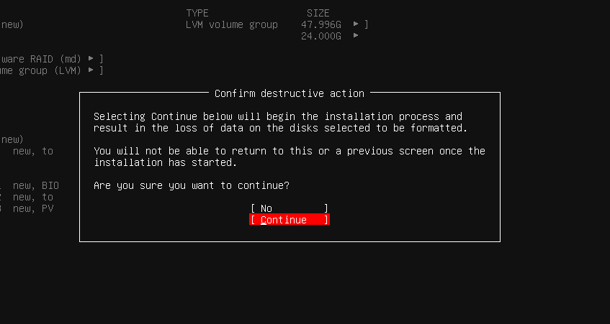

Fill the profile detail and using tab go to done, and press Enter
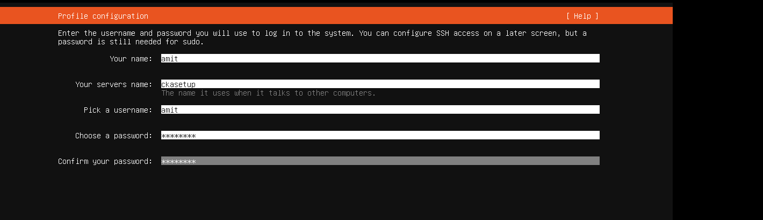

Press enter
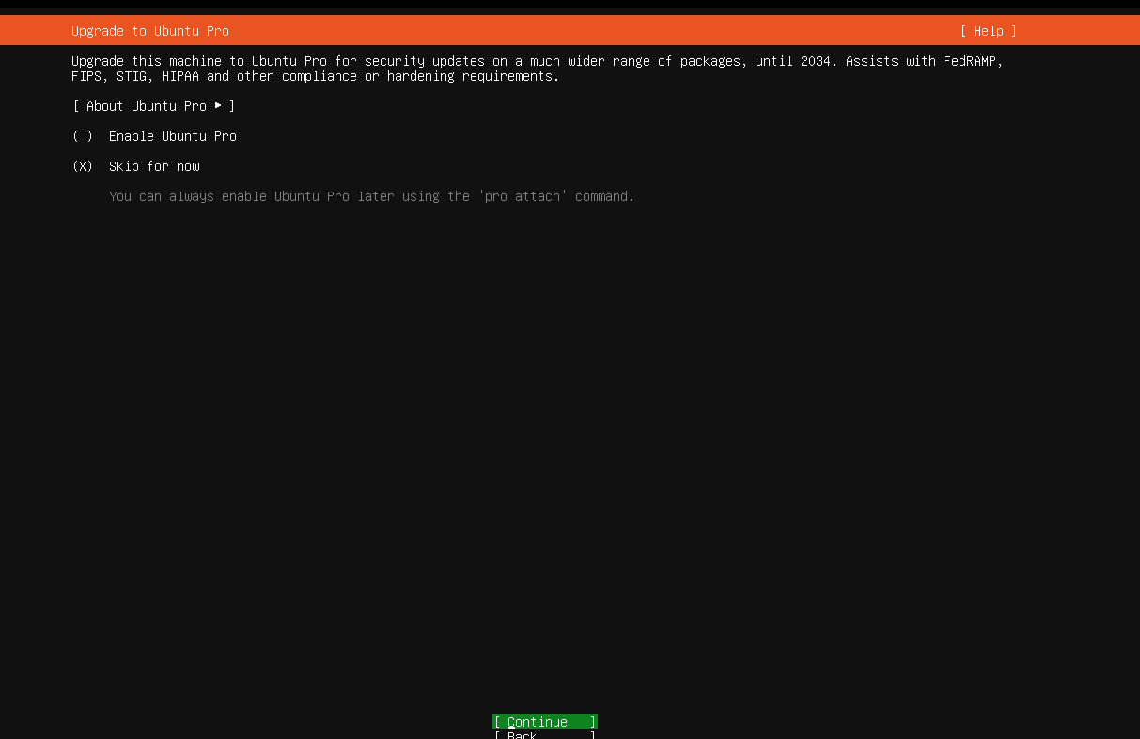
Using Space bar , select insall openssh , press tab and Enter on done
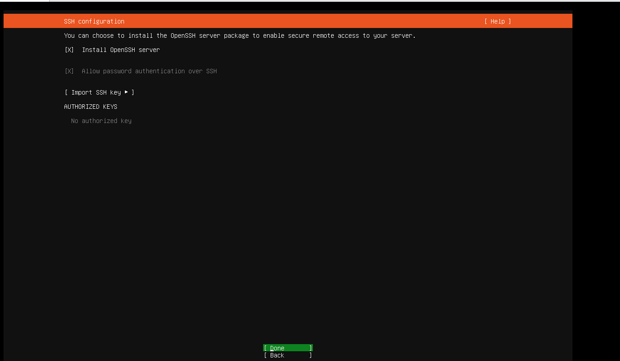

No need to select any module, press tab and enter on done
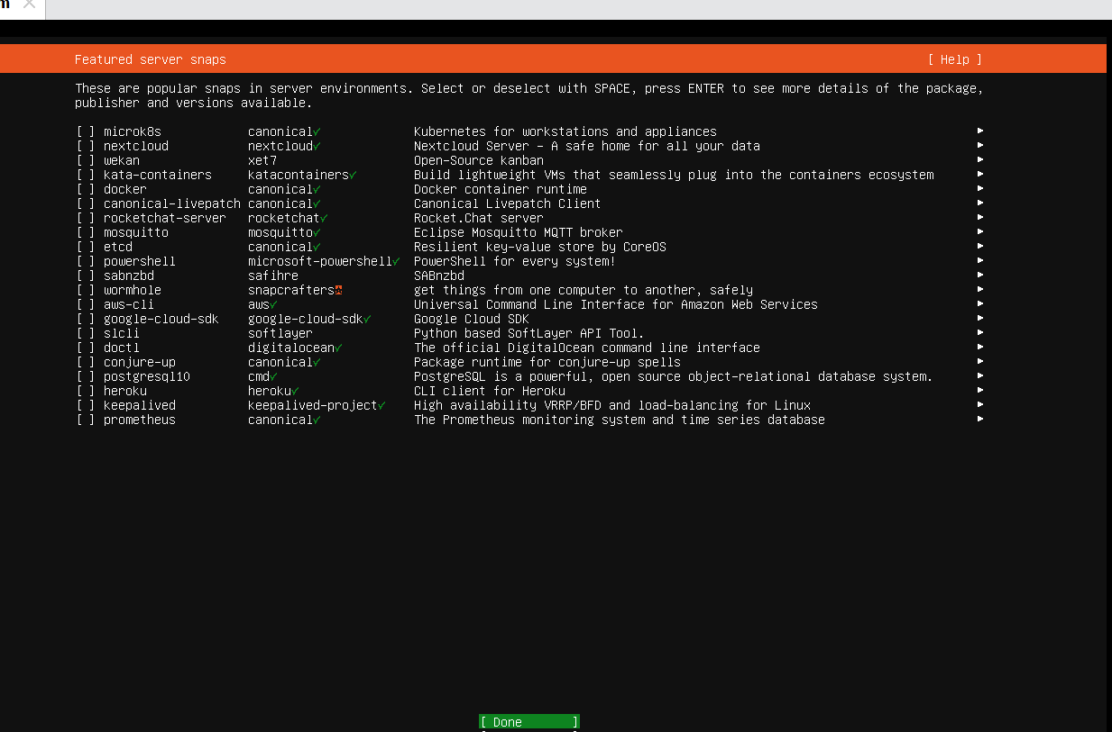

Once Installation is finished, press tab and enter on reboot now

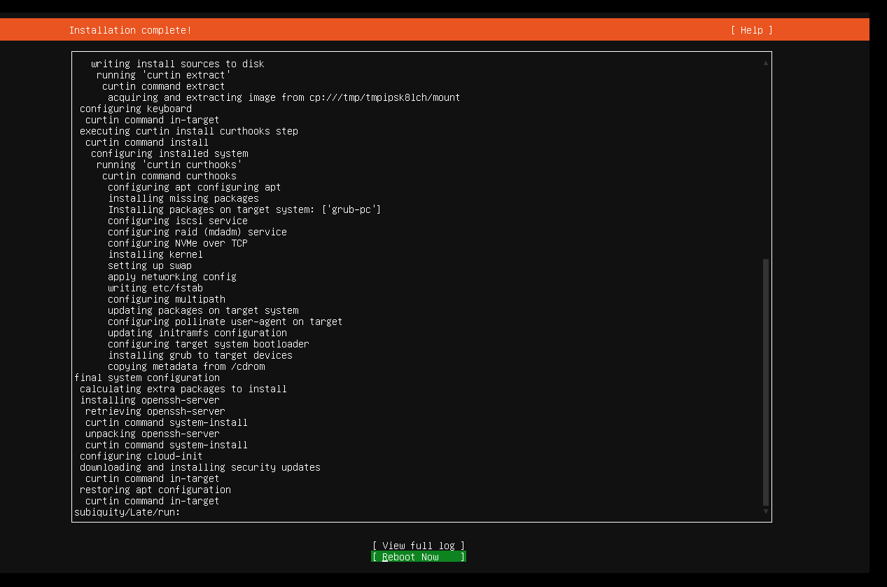
Press Enter
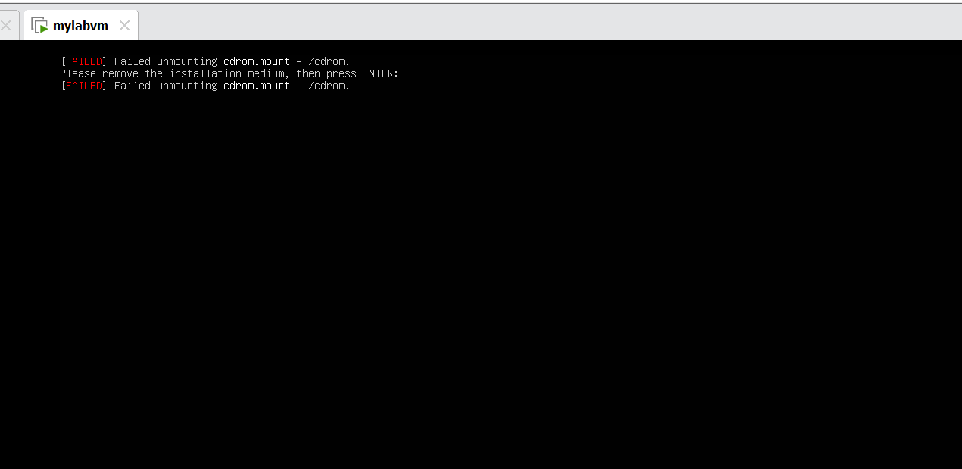
Once system is booted, login with your user

Note down the ip address
